

An Assignment on:
“Agro-ecotourism Model Villages of Nepal”

Submitted by: Submitted to:
Sunil Ghimire Dinesh Bhatta
Department of Soil Science and Agri-engineering Assistant Professor
Roll no.: SSC-01M-2018 AFU, Rampur, Chitwan

June 7, 2021
Introduction
Agro-tourism is the emerging industry in the tourism sector which open the gateway for the visitors to the agriculture farm and ranch. It involves the various activities related to the agriculture like feeding, milking of animals, production of the crop packaging, honey making, nursery management, rearing of earthworm, horse riding etc.
Agrotourism is a style of vacation which is normally on farms. This may include the chance to help with farming tasks during the visit. Agro tourism is developing into a large part of the tourism industry and will soon be one of the largest sectors of tourism. People are more interested in how their food is produced and want to meet the producers and talk with them about what goes into food production.
Nepal has plenty of natural resources, which makes agro-tourism more popular and fascinating among tourists. During the summer season you will be exhilarated to see the farmers being involved in rice plantation. The techniques they follow for plantation and harvesting differs from one region to another. The laborious farmers turn their field into an opera theatre where they sing local songs and exchange funny remarks to avoid the sluggishness and sense of hard work. In winter season fields are adorned when wheat plant starts sprouting across the land. Not limited to this, every season is rich in its agricultural product and provides the tourists a life time experience.
Rice, wheat and maize are the major crops of Nepal. Farming systems and crop production in Nepal vary across the agricultural zones. Physically, the country is divided into four ecological strata: the southern terai plain; the southern mountain ranges; the central hill complex; the northern great Himalayas. Rice-based cropping systems, with wheat or maize as a secondary crop, are predominant in the terai and middle hills, whereas in the high mountains maize, millet, barley and buckwheat are cultivated. Tea, cardamom, ginger and coffee are the important cash crops of the middle hills. Likewise, wide ranges of temperate fruits in the high mountains; citrus in the middle hills; tropical/subtropical fruits are also grown in the terai and middle hill valleys. Vegetable-growing in kitchen gardens is practiced at all elevations. In addition to this Livestock is an important component of the Nepalese farming system providing food for humans, manure for plants, and draft power for farms and cash income for farm families. Cattle, buffaloes, sheep, goat, pigs and poultry are the livestock species reared across different agricultural zones.
Agro tourism has various different economic and socio-cultural aims. The basis of the program is the revitalization of the countryside and reversal of urban trend. It brings tourists to the countryside instead of over populating cities. You can meet lovely and hardworking people of rural area, share a meal with them, stay at their houses as family guests, taste their local drink and see them carry on with life graciously. In addition, to the heartwarming hospitality, you will also witness some of the most spectacular views of the mountain landscapes or heritage sites along the way.
Establishing the agro model villages or home stays is one of the important aspects for fascinating the tourist in the remote areas. The agro-villages provides a set of full satisfaction to the tourist. Tourist always wants to know different news things, do different new activities, taste different items. In this scenario, the agro-villages of Nepal can provide such different activities. For instance, a tourist to a agro farm or agro village can do the farming activities that are typically origin of that place. Tourist can themselves harvest different vegetables or fruit and can consume. They can play with farm animals, milking of the farm animals, riding on them, etc. Besides, the typical culture, tradition and way of life of different rural villages can be the center of attraction for the tourist.
The government of Nepal has also given priority for the establishment of model agro villages in different parts of the country. Agriculture ministry is planning to develop five such villages across the country such as; Ghodaghodi in Kailali, Machhamara in Sunsari, Rautamai in Udaypur, Patle in solukhumbu and kakani in Nuwakot. The ministry has aimed to increase the area accordingly if it becomes successful and to be promoted as ‘Modern Green Tour Village’. Likewise, the Gandaki province has initiated the to make 36 climate smart villages i.e. Eco-friendly model agro village on march 24, 2019. Here are some of the agro-ecotourism model villages of Nepal which are used as destination of both national and international tourist in Nepal.
Agro-ecotourism model villages of Nepal
- Ghale Gaun
Ghale Gaun lies in Gandaki province of Nepal, located in the Northern part of Lamjung District, which is approximately 205 km North West of Kathmandu and 125 km north east of Pokhara. The typical Gurung village is situated at the height of 2100 m from the sea level. Ghale gaun is probably the only place of Nepal from where we can see the nine different district of Nepal as well it also commands a superb breathtaking view of majestic western Himalayas including Dhaulagiri Range, Machhapuchhare/Mt Fishtail (6693m), Annapurna 1st (8091m), Annapurna II (7939m) Annapurna IV (7525m), Peak 29 (7,871 m), Lamjung Himal (6,983), Bouddha Himal (6974m), Himalchuli(6747m) and many more smaller peaks and botanical garden, historical uttankanya temple and tea garden are the major attraction of this village. Ghale Gaun which is better known as its warm hospitality and SAARC no. 1 destination for the visitors from the past few year. Ghale Gaun was named as second village tourism destination after Sirubari of Syanja after 2056 B. S. Ghale Gaun has been recently crowned as the No. 1 village tourism destination in SAARC Region.
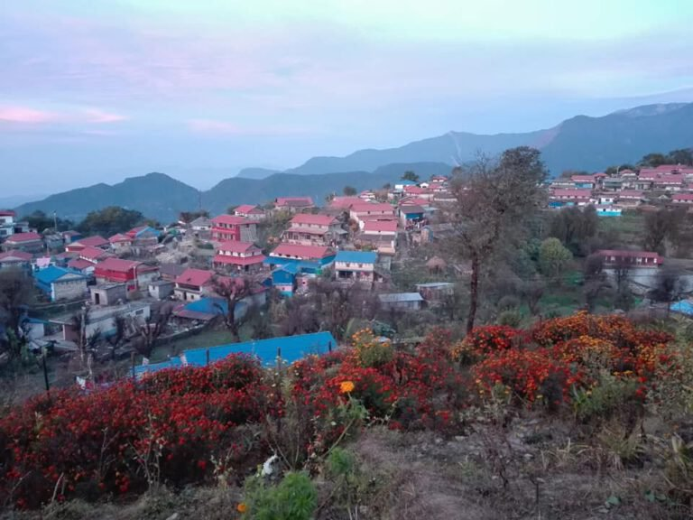
There are around 115 houses in this village.
Ghale Gaun has its own uniqueness. Visitors are
welcome with Mala (garlands) on neck and Tika
on forehead with traditional music and songs by
the women’s group (Aama samuha) of the village.
Guest is treated as their family member. The
people of this village are honest, loyal, social
and laborious. Villagers wear their traditional
dresses, both by man and women. Agriculture,
animal farming, joining to British and Indian army
is the main occupation of the people here. Fig.: Photo of Ghalae Gaun

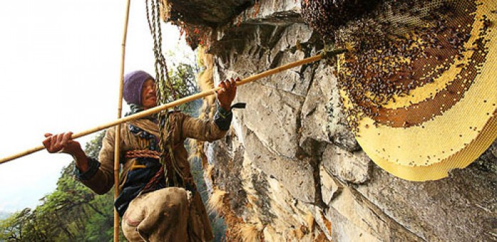
Honey Hunting is also one of the main attractions of
Ghalegaun. People use their experienced skills and
hang on a cliff 300 meters above with the help of
Bamboo and hemp ropes to harvest the honey from
Bhir mauri. Also, we can see the view of sun rise in
the morning. Ghale Gaun has also built a Gurung
museum house, where visitors could see the daily
house hold use tools, agricultural tools, cultural
dresses and local musical instruments. Ghale Gaun Fig.: Photo of Honey hunting

is culturally reach, they perform different kinds of dances as per the occasion; such as Ghatu dance (on the full moon day of Baisakh), Aarghau (main traditional ritual performed after the death). Similarly other dances are putputte, lama dance, pachhyu dance, Ghyabre dance etc.

- Siru Baari
Sirubari Village is situated in Syangja district of Gandaki province. It lies in the south west of the Pokhara. Village is situated 1700 m above from sea level. The concept of Village tourism was firstly introduced in Sirubari Village. Many village tourism products of Sirubari are in market nowadays like ‘Sirubari Topi’ is famous now. The village start initiate different than others. Sirubari village tourism started in 1997. The most interesting part in Sirubari is management done by local people to introduce their culture, tradition. Tourist are more interest in this village because of the local people. They provide accommodations, local foods, drinking water facility, walking experience, etc. Sightseeing, village houses, Annapurna Mountain range view is main doing activities over here. Gurung culture and tradition, local food production, local tourism materials are the major attraction of Sirubari village.
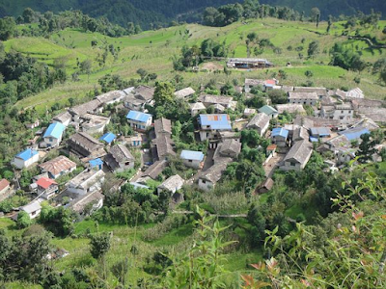
Sirubari Village is located in uphill with beautiful view
of nature. The main occupation of people living here is
agriculture and second is tourism. They produce Maize,
wheat, barley, and many other foods. People of village
crop down Kitchen Garden vegetables and sell down
to the town. They provide accommodation themselves.
Their source of economy is tourism. Sirubari Village is
very reach in Flora and Fauna. They preserve every
creature beautifully. There are around 60 houses in
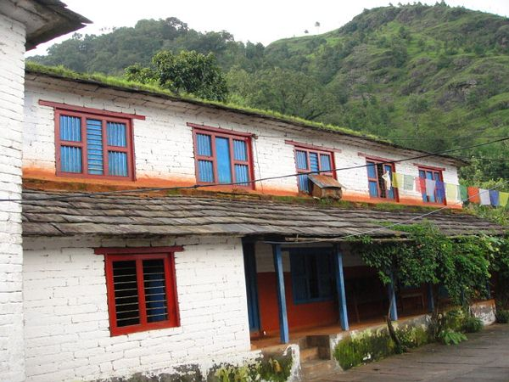
Sirubari. Fig.: Photo of Sirubaari Village
They provide accommodation with Gurung life Style.
The houses are built with local materials. The houses
are beautiful and comfortable. Sirubari village is a
village full of culture, tradition and heritage of Gurung
life style. They perform dances like Ghanto Naach,
Maruni Naach, Sorathi Naach, etc. Men and women
sing Dohori song like battle.
Fig.: A typical house in Sirubaari
Sirubari won PATA Golden Award 2001 in heritage and culture.

- Bandipur
Bandipur is a hilltop settlement which is located in Tanahun district of Gandaki province. It is located at an elevation of about 1030 masl. Its is about 143 km from Kathmandu and 80 km to east of Pokhara. Bandipur has retained its age-old cultural attributes - temples, shrines, sacred caves, innumerable festivals, and a Newari architecture. Because of its preserved, old time cultural atmosphere, Bandipur has increasingly been coming to the attention of tourism
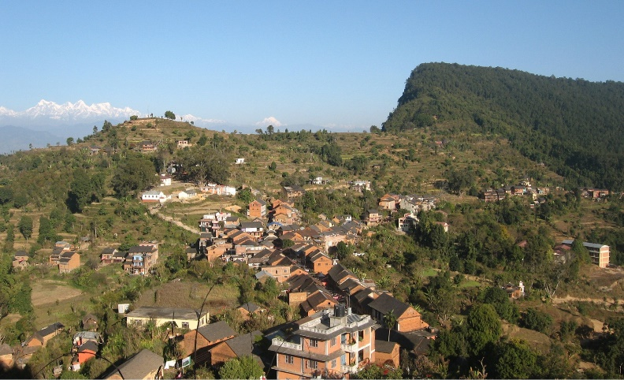
The houses in Bandipur have typical Newari
architecture. A distinctive aspect of Bandipur's
main street is covered with slate slabs and houses
with veranda extending along almost the entire
length on the northern side. Most of the buildings
still have little shops in them. Formerly a Magar
village, Bandipur today is settled by a variety
of Nepali ethnicities with different beliefs: the
Bahuns, the Chhetris, the Newars, the Damais,
Kamis,Sarkis, the Magars and Gurungs. The
various Newari and Magar festivals, which until
recently have been held for their own purposes Fig.: Photo of Bandipur village
several times a year, can be of interest to tourists too.
Sorathi and Chutka dances are very popular. Other attractions include the Bindyabashini temple and the library in the village centre, Thani Mai, Tindhara (“Three Taps” washing place at the southeastern outskirts), Raniban (Queen's Forest), the downhill trek to the Siddha Cave and a hike to Ramkot village. On Mukundeswari, the elevation at the western end of the saddle is a little shrine and one has a view of Bandipur itself.
Tourist can enjoy with ripen oranges, picking and consuming themselves. There is a mulberry tree plantation and silk farm at bandipur where tourist can observe the raw and unprocessed silk and the fine silk products. Tourist can also observe the goat research center where we can see different species of goat before reaching to bandipur.
Due to it sound and peaceful environment with full of natural beauty it is named as “Bandipur- Where the Heaven meets”

- Amaltari Village Homestay
Amlatari village homestay is dominant of Tharu community. The Amaltari homestay program established in 2013 by local entrepreneurs with help from the government and WWF. This village is located in nawalparasi district (Bardhaghat-susta east) of Gandaki province of Nepal.
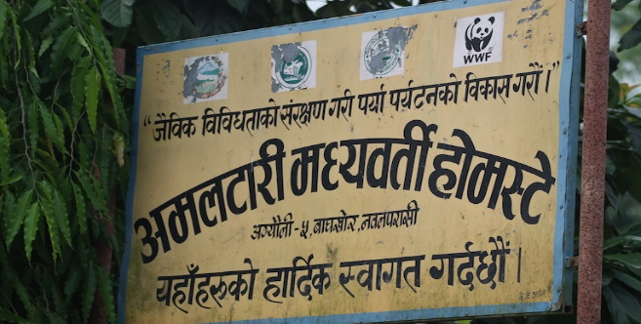
The homestay program here is run by local communities and supported by WWF Nepal in the Terai Arc Landscape, the hugely biodiverse lowlands along the Nepal-India border. They were established with the threefold aim of safeguarding the environment and wildlife, providing economic benefits, and ensuring social justice.
The guests in the village are welcomed with traditional
garlands and flowers. They are served with all the local
foods according to their traditions and culture. Fishes
caught by themselves are served as a special dish. The
local people perform their tradition culture like dance and
song by gathering the visitors at special place at night after
their meal. Tourist and visitors can also enjoy with them.
Tourist can go for a view of wild animals like Rhino,
Elephant, Tiger, etc. near the river bank. Fig.: Welcome board of Amaltari Village Homestay

Amaltari village homestay was awarded the best homestay program in 2017 by the ministry of tourism.

- Fulkharka Village
Fulkharka is located in Dhadhing district of Nepal in the southern slope of 2,900 m hill in the foothills of Ganesh Himal Range. Agritourism in Fulkharka village is about traditional rice farming. It starts from June / July and lasts till October. Agritourism and agricultural volunteer is about learning the traditional terrace farming in Nepal and helping them by the means of tourism.
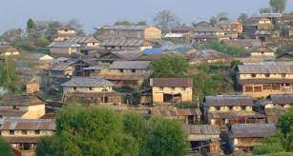
Fulkharka homestay is a great opportunity to experience
daily chores of the agricultural community of Nepal.
Tourists can participate in butter making process,
gardening, animal farming, basking of crops, beaten
rice making and many other traditional chores. The
means of accommodation during the stay will be
homestay. Under the Fulkharka homestay program,
tourists will go and stay with local family. Homestay
houses are selected with their hygienic adaptation in
daily life. Fig.: Photo of Fulkharka Village
As Fulkharka is located in the of Ganesh Himal Range, there are several walks to the ridges on all sides offering magnificent view of Ganesh Himal and Manaslu Ranges. Ganga Jamuna cultural trek comprises the highlight of Ruby valley and Ganesh Himal trek.

- Purankot Kaulepani Homestay
Purankot kaulepani Homesta, Duradanda is located in Lamjung district of Nepal. It is a three hour walk form Sundarbazar, a village market. Facing east, it lies between river Kirenche in the east and Paudi River in the south and Chadreswar Village in the west
This historical village is a Gurung’s village situated on the lap Purankot peak. Tourists will soon have the opportunity to hike between these beautiful villages with breathtaking views of the Annapurna Mountain range. They will stop along the way to experience cultural activities, sample local cuisine, and enjoy the hospitality of village families while staying the night in one of their charming traditional homes.

- Lwang Ghalel Homestay
This village is located just about 30 km Northeast of Pokhara. It is one of the most successful village tourism spot in Nepal. The tourism can participate and learn the village life, observe feeding and milking cattle, churing of the yoghurt and making butter, traditional way of grinding cereals to make flour for the meal. Similarly, tourist can learn about their custom and help them prepare a meal.

