Practical 5: To develop an agro-ecotourism guide for Nepal

Full Itinerary & Trip Details

Explore Nepal:
From a New Perspective of Agro-Eco Tourism

An 11 Days tour guide

Trip Overview:
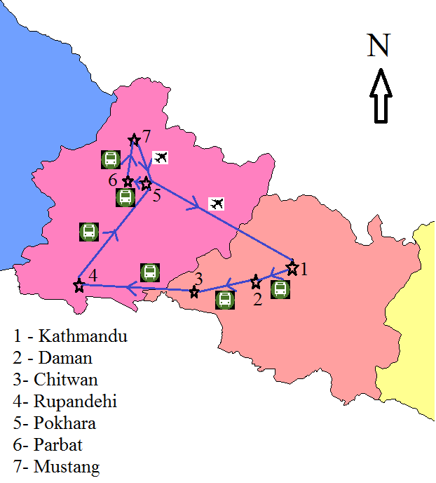
PRICE STARTING FROM  800 US$ | DURATION  10 Days
IDEAL AGE  From 5 to 85 year olds | STARTS IN >> ENDS IN  Kathmandu >> Kathmandu
STYLE  In-depth Cultural | OPERATED IN  English
OPERATOR
Nepal Agri-Eco Explorers

Itinerary

Introduction

Day 1: Arriving Kathmandu
Start Point: Kathmandu, Nepal
Arrive in Kathmandu airport and greeting with Nepali flowers. Evening welcome dinner at a traditional Nepali farm stay with traditional food items and cultural dances.

Day 2: Kathmandu-Daman (Visit of Vegetable pockets of Palung)
After breakfast, we will travel to Palung and have our morning meal there. Palung, a well-established vegetable pocket area is at a distance of 3 hours’ drive from Kathmandu. We will visit different farms, and observe typical Nepali agriculture system. We will then travel to Daman, visit Temperate Horticulture Nursery Centre and spend the night there.

Day 3: Daman – Chitwan
After breakfast, drive 4 hours to Chitwan and have our morning meal. Chitwan is a well-known poultry and agriculture hub. We will visit different orchards, vegetable and poultry farms and spend our night at “Traditional Tharu Farm stay” with traditional food and dances.

Day 4: Chitwan - Madhawaliya
After breakfast drive to Madhawaliya, Rupandehi. It will take around 5 hours to reach there. After morning meal we will visit Ostrich farm, and spend our day there. We will return to Butwal and stay in a hotel that night.

Day 5: Butwal - Pokhara
After breakfast, drive to Pokhara. After all these days of driving, we will take a rest at Pokhara for refreshment. Pokhara is known for lakes and beautiful view of mountains. We will stay at a hotel in lakeside and enjoy boating and sight-seeing.

Day 6: Pokhara - Sardikhola
After breakfast, we will drive to Gandaki Trout Farm, Sardikhola. This farm is well known for rainbow trout farming. We will spend our day there, visiting and having different trout dishes.

Day 7: Sardikhola - Parbat
After breakfast, we will drive to Parbat and spend our day at Bee farm, Deupur. This area is also renowned for vegetables and mandarin. Here, you can harvest fresh vegetables from farm and enjoy cooking in Nepali style. We will have a camp fire and enjoy traditional Nepali dances.

Day 8: Parbat – Mustang
After breakfast, travel to Mustang. Mustang is situated in the laps of Himalayas and is known as the hidden paradise. It takes around 7 hours to reach Jomsom via bus. We will stay in an Apple farm stay and enjoy the Thakali food and culture.

Day 9: Mustang
Visit apple farms on this day. Various apple products are available on the farm which could be taken back to your country. Besides, we will also visit potato, and buckwheat farms. We will also stop in various places for sightseeing.

Day 10: Mustang – Pokhara – Kathmandu
Return to Kathmandu via Pokhara through airways. Arrive in Kathmandu and check in at hotel and evening visit to Swyambhunath, a 2000 years old Buddhist monument looking out into the four cardinal directions, is situated on a hilltop overlooking the Kathmandu city. It is one of the world's most glorious Chaityas about 3 km from the city center. Surrounding the hemispherical Stupa are many temples and pagodas and large band of red-faced monkeys, believed to be the descendents of 'Hanuman', the Monkey God.

Day 11: Final Departure
End Point: Kathmandu, Nepal
This will be your last day in Nepal. So, you can spend all your free time to do some shopping, relax at the spa. Transfer from hotel to airport to catch international flight.

What’s Included?
Accommodation
Accomodation in Kathmandu Butwal & Pokhara using three star hotels,
Accommodation in farm and home stays stays in other places.

Guide
Professional local guide with extensive experience trained in Wilderness First Aid and accredited by the Nepalese government.

Meals
Full board meals (breakfast, lunch and dinner)

Transport
Tourist bus drive from Kathmandu - Mustang
Domestic flights from Mustang – Pokhara and Pokhara – Kathmandu

Departure Dates
STARTING IN Kathmandu >> ENDING IN Kathmandu
05 July 2021 15 July 2021

09 July 2021 19 July 2021

13 July 2021 23 July 2021

17 July 2021 27 July 2021

21 July 2021 31 July 2021

25 July 2021 04 August 2021

29 July 2021 08 August 2021

02 August 2021 12 August 2021

06 August 2021 16 August 2021

