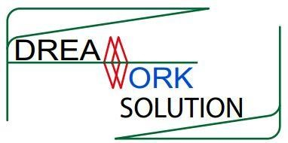
PAN: 301862859

DreamWork Solution

A Report on “Farmer Family Annual Production Plan”
कृषकको पारिवारिक उत्पादन योजना

Submitted By: DreamWork Solution Bharatpur-12, Chitwan
Website: dreamworknetwork.com Email: itchitwan@gmail.com Contact: 056-522343

Contact Person:
Kiran Bamanu
Program Manager
DreamWork Solution
Email: kiranbamanu@gmail.com Mobile: 9855024158

Submitted To:
Agriculture and Livestock Development Section
Pokhara Metropolitan, Pokhara

Farmer Family Annual Production Plan
Data of Production is the precious for proper planning and executing the services timely effectively and efficiently.
Farmer Family Annual Production Plan is the feature for gathering the data of farmers annual production plan. This feature has been managed in the existing Agriculture Production Management System (apms.pokharakrishi.com).

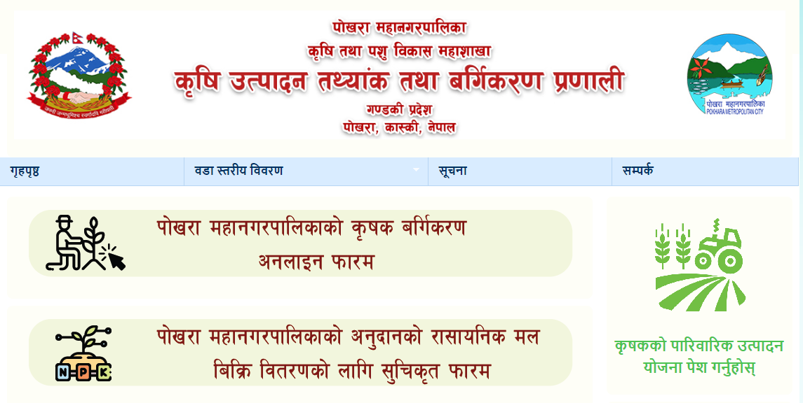
Fig: Addition of Feature “Farmer Family Annual Production Plan”

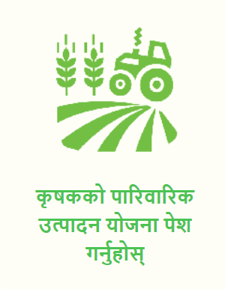Click on this button for providing the information and data.

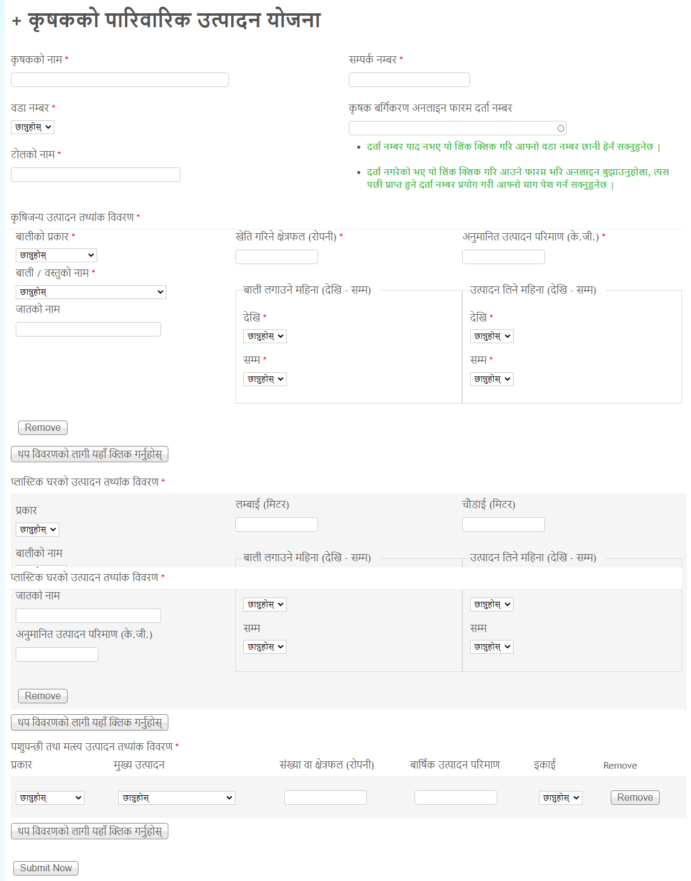

The details can be filled up as below:
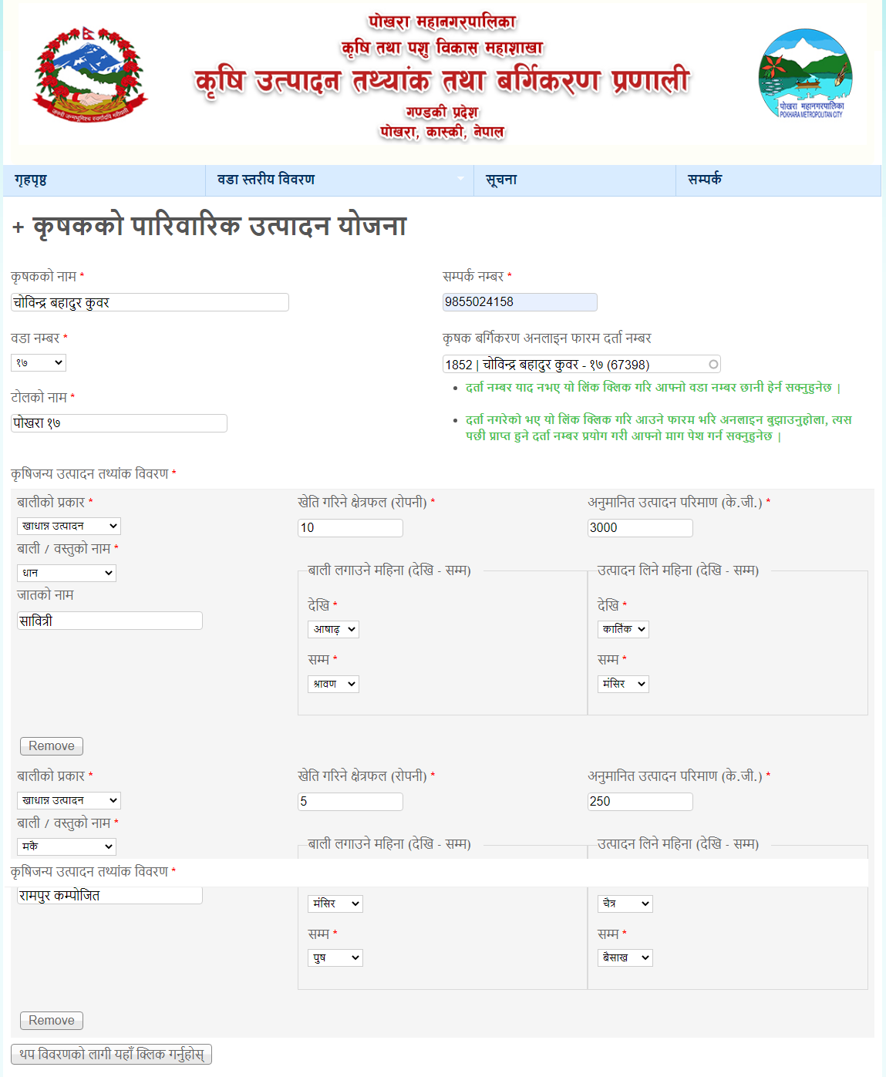

After submitting the details, following page is displayed.
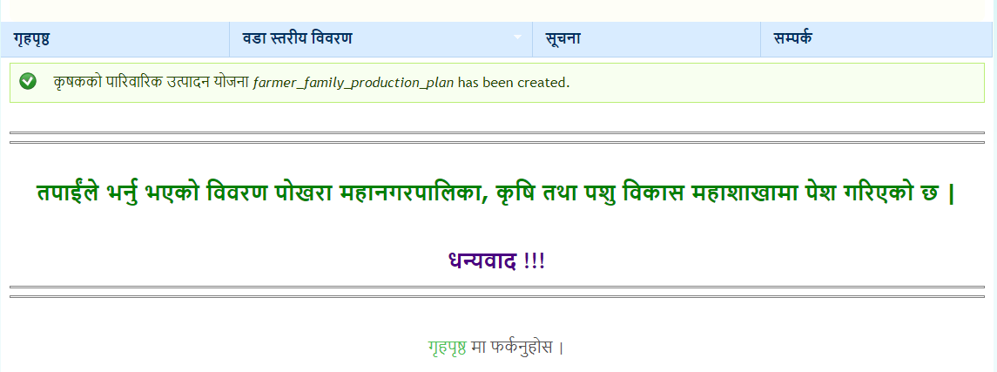

After login, the details can be viewed and managed.
