Practical no: 3
Identify the different marketing strategy for agro ecosystem products.

1. Introduction
Marketing is the process of determining what customers want, and of using that information to produce and sell a good or service to satisfy that want. It also includes a clear description of the goods, services, and experiences offered and advertising and promotion of your agritourism business.
Marketing strategy is a plan of action designed to promote and sell a product or service to obtain the profits. A marketer should watch market situations to identify the stage in which the product is passing through, and accordingly, he should design appropriate marketing strategies.
Agro tourism is the economic activity which links travel to the agriculture. Key agribusiness products prominent in agritourism include wine, craft beer and spirits, gourmet foods (cheese, olives, condiments, and confectionary), fruit, vegetables, nuts, meat and seafood. Agro-Tourists prefer fresh products such as eggs, milk, fruits, processed farm products etc. and many other farm products are always available for agro-tourists to buy.
The terms marketing plan and marketing strategy are often used interchangeably because a marketing plan is developed based on an overarching strategic framework. In some cases, the strategy and the plan may be incorporated into one document, particularly for smaller companies that may only run one or two major campaigns in a year. The plan outlines marketing activities on a monthly, quarterly, or annual basis while the marketing strategy outlines the overall value purpose.
The 4 P's" are product, price, promotion, and place. These are the key factors that are involved in the marketing of a good or service. The 4 P's can be used when planning a new business venture, evaluating an existing offer, or trying to optimize sales with a target audience. It can also be used to test a current marketing strategy on a new audience.

4. Literature Review

4.1Marketing Strategies has four stage
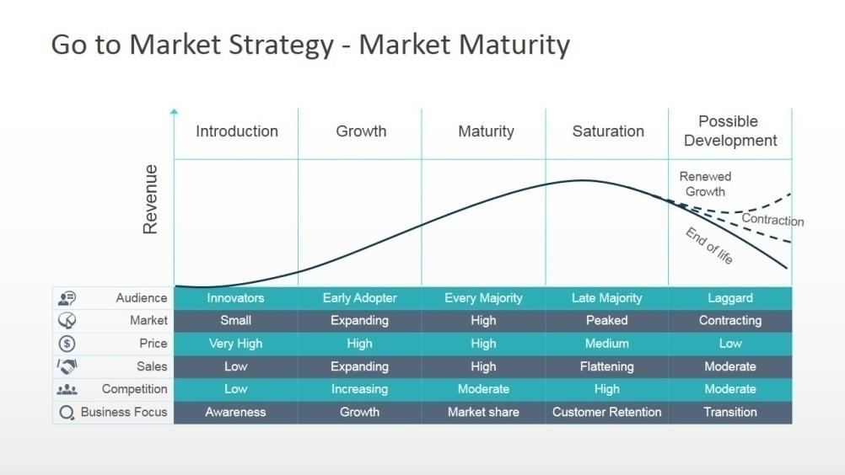

4.1.1 Introduction stage
It is the first starting phase in marketing process which marked with slow growth in sales and a very little or no profit. As the product has been newly introduced, and a sales volume is limited; product and distribution are not given more emphasis.
Possible Strategies during introduction phase
1.Rapid Skimming Strategy:  This strategy consists of introducing a new product at high price and high promotional expenses. The purpose of high price is to recover profit per unit as much as possible. The high promotional expenses are aimed at convincing the market the product merits even at a high price. It is preferred to skim the high profits from market. | 2. Slow Skimming Strategy:  This strategy involves launching a product at a high price and low promotion. The purpose of high price is to recover as much as gross profit as possible. And, low promotion keeps marketing expenses low. This combination enables to skim the maximum profit from the market.
3. Rapid Penetration:  The strategy consists of launching the product at a low price and high promotion. The purpose is the faster market penetration to get larger market share. Marketer tries to expand market by increasing the number of buyers. They prefer the low-priced products. i.e price sensitive. There is strong potential for competition. Per unit cost can be reduced due to more production, and possibly more profits at low price. | Slow Penetration:  The strategy consists of introducing a product with low price and low-level promotion. Low price will encourage product acceptance, and low promotion can help realization of more profits, even at a low price. It may br due to market is large. Market is aware of product. Possibility of competition is low. Buyers are price-sensitive or price-elastic, and not promotion-elastic.

4.1.2Growth Stage:
The aim is not to increases awareness, but to get trial of the product. Company tries to enter the new segments. Competitors have entered the market. The company tries to strengthen competitive position in the market.
- Product qualities and features improvement
- Adding new models and improving styling
- Entering new market segments
- Designing, improving and widening distribution network
- Shifting advertising and other promotional efforts from increasing product awareness to product conviction
- Reducing price at the right time to attract price-sensitive consumers
- Preventing competitors to enter the market by low price and high promotional efforts

4.1.3 Maturity Stage:
In this stage, competitors have entered the market. There is severe fight among them for more market share. The company adopts offensive/aggressive marketing strategies to defeat the competitors.

Following possible strategies are followed:
a. To Do Nothing:
Company believes it is advisable to do nothing. Earlier or later, the decline in the sales is certain. Marketer tries to conserve money & later on invested in new profitable products starts planning for new products.
b. Market Modification:
There should increasing sales by raising the number of brand users and the usage rate per user or by both. Convert non-users into users by convincing them regarding uses of product, entering new market segments, Winning competitors’ consumers.
c. Product Modification:
Product modification involves improving product qualities and modifying product characteristics to attract new users and/or more usage rate per user.
i. Quality Improvement:
Quality improvement includes improving safety, efficiency, reliability, durability, speed, taste, and other qualities. Quality improvement can offer more satisfaction.
ii. Feature Improvement:
This includes improving features, such as size, color, weight, accessories, form, get-up, materials, and so forth. Feature improvement leads to convenience, versatility, and attractiveness.

d. Marketing Mix Modification:
It involves changing the elements of marketing mix. This may stimulate sales. Company should reasonably modify one or more elements of marketing mix (4P’s) to attract buyers and to fight with competitors.

1.1.4 Decline/Saturation Stage:
The first important task is to detect the poor products. After detecting the poor products, a company should decide whether poor products should be dropped. Some companies formulate a special committee for the task known as Product Review Committee. The committee collects data from internal and external sources and evaluates products. On the basis the report submitted by the committee, suitable decisions are taken.

Follow any of the following strategies:
1. Continue with the Original Products:
company continues its products only in effective segments and from remaining segments they are dropped. Such products are continued as long as they are profitable.
2. Continue Products with Improvements:
Qualities and features are improved to accelerate sales. Products undergo minor changes to attract buyers.
3. Drop the Product:
When it is not possible to continue the products either in original form or with improvement, the company finally decides to drop the products.

4.2 Different marketing strategy followed at agro ecotourism produce
A right marketing strategy plays an important role in the success of a business. Every company chooses and spends a lot of money for the right marketing strategy to boost their sales. Powerful companies opt for more than one marketing strategies.
Key to remember
- Determining your audience first will help choose the key selling points for your marketing strategy.
- Marketing can be as simple as word-of-mouth referral, or involve an intensive regional, national, or international media campaign.
- Your marketing style and message must be directed to your identified audience.
- Keep your message simple & always check dates, fees, addresses and phone numbers for accuracy.
- Advertising is the most expensive approach there should carefully consider all the following mediums and focus on those that fit your budget and reach your target audience.
- You may decide to target your service based on the characteristics of: income level ,age , location, client
- The cost of marketing for a fee-recreation enterprise will largely depend on the size and type of your operation, the medium you select, and the number of times you repeat any advertisements.

4.2.1 Direct selling the agro product
There are few products which can be sold by meeting your customer’s face-to-face (mushroom, honey, fresh leafy vegetables) and providing them a demonstration of your products. For example, if you selling a product used at home. You can call a group of customers in one person’s home and can provide a demonstration about how that product works. This market strategy is less expensive but works for a few products and it requires sales skills and an extrovert personality to convince your customers to buy products.

4.2.2 Point-of-purchase marketing:
Point-of-purchase marketing strategy includes placing your agro-product where customers make the most purchase. You must have noticed that many small products are being placed near the cash counter. This is done intentionally so that people make an impulse purchase. Eg. Travelling to palpa for visiting we can find the batuk and chukauni at the point where vehicles stop for the purpose of breakfast.

4.2.3 Word-of-mouth:
Traditionally, word-of-mouth advertising has been practice mostly on vegetable crops, street foods meat, Fish, fresh where the seller goes individual door and ask for buy. Nowadays, the method of this type of marketing has been changed. These days’ people have a tendency to read reviews about everything before making a purchase.

4.2.4 Digital marketing

Digital Push
The “push” part allows you to get in touch with consumers and inspire them to buy your service or product. You can use technologies such as instant messaging, text messaging, content marketing, podcasting, mobile marketing, and email. Also, there are many marketing tools you can use like pay-per-click, search engine optimization (SEO), and even online banner advertising.

Digital Pull
The “pull” technique occurs when consumers take the initiative to locate your business via an online search via digital marketing. For instance, they may perform a search on the internet using your name. The customers then establish a link, via your website, where they can easily contact your company or keep track of your business. For example, they may sign up for text messages, streaming video, emails, newsletters, or podcasts on your website. So, you’re pulling in, or attracting.

4.2.4.1 Social media

Farm enterprise pay a lot of money to promote their agro products on various media platforms like newspaper, television, social media etc. Many agro products like high vale cash crops, immersing fruit crops dragon fruit avocado, kiwi, strawberry. Many processed agro-product cane juice, grapes, apple wine dry fruits etc. They even pay Celebrities to promote their products. People trusts earned media than any other sort of promotion.

4.2.4.2 Internet marketing:
Internet marketing includes various marketing from social media, blogs, email, blogs. Any type of marketing that you conduct on the internet is called internet marketing. However, internet marketing requires a strategy that how and when you post your posts and how you encourage people to purchase your product. People invite to like/join their page/ group so that your every important post can be seen to your timeline. Marketing of agro product nationally or internationally helps by internet medium.

4.2.4.3Co-branding and affinity marketing:
By using this marketing strategy, you share your customers with businesses that compliment your own business. For example, if you are selling wild honey related products like a Honey mad, organic honeys you can tie up with a famous Ayurividec instructor to promote your products by sharing a percentage of profit with them. If you follow yoga instructors on Face book you must have seen them promoting products of certain brands. It is clear that co-branding or affinity marketing represents a partnership between two businesses with similar interests. They aren’t competitors to each other. Hence, there is no fear of losing your customer base. Affinity marketing refers to creating a product with another business to boost its sales.

4.2.4.4Influencer Marketing :
This type of marketing involves online influencers like bloggers, YouTube’s to recommend your products and services to their audience. You can either give away free products or pay them to promote your business. Every influencer has its own terms and conditions. You should discuss with them before lending into partnership.

4.2.4.5Inbound Marketing :
This type of market strategy is effective when you want to build a positive relationship with your prospect audience without spending too much money. This includes marketing strategies which attract your customers to your business like a magnet. You can make your presence visible on social media use an email list to share free content. As people have become blind to television advertisement these days. This type of marketing strategy will surely get their attention.

4.2.4.6Content Marketing :
This type of strategy involves sharing the content that you write of your blog or landing pages to social media platforms. It is one of the effective marketing strategies because it gets organic traffic to your blog and converts visitors into loyal followers. You need to upload value-rich data constantly to keep your followers. Therefore, you should plan your content months in advance.

4.2.4.7Retargeting:
Using this type of marketing you target people who have shown interest in your business before. For example, Face book let you place a pixel on your website. A user will see the ad of your product on Face book if he/she has recently visited your website. As they already know about your brand, they will recognize it and there are high chances for them to get convert. There are other retargeting platforms too like Instagram, YouTube etc. where you can retarget your prospects.

4.2.4.8Referral Program:
This type of marketing strategy makes the use of your existing customers to get new customers on board. You pay some incentive or benefits to your customers if they ask their friends to buy your product or service. People usually do word-of-mouth marketing to get the benefit. The amount you pay to them is quite small in front of the returns you are getting. Find the way to keep the track of referrals done by your customers before giving them benefits.

4.2.4.9Story telling:
Storytelling is an emotional way to reach your audience. You can produce personal stories, brand stories or a story of one of your customers after taking their permission. There is one more trend of saying a story in exactly six words. Here writer requires great writing skills to create a short meaningful story. This type of marketing strategy helps you to win the trust and loyalty of your customers.

Why digital marketing is getting popularity in the Nepal?
Digital marketing is very cost-effective for small businesses. You can reach a wider audience on the internet than you ever could with other medium, can also engage directly with your target audience and encourage them to take the desired actions – something that’s impossible to do with traditional advertising methods. The easier the platform is to use for you and your audience, the better. This will help in your relationship marketing. That’s because if it’s easy for them to use, then they’re more likely to be spending a lot of time there social media marketing forms a symbiotic relationship with your other marketing efforts can combine it with other forms of content or brand marketing, like photos, webinars, videos, your website links, etc. According to psychographic data, social media targeting is unmatched in terms of targeting can laser-target just about demographic by any metric imaginable (personality, habits, interests, location, etc.). This is beneficial for your direct marketing especially if you have new products to promote

4.3 Cereal crop marketing strategy
In the short term, policy should be focused on providing production inputs, chiefly high yielding seed varieties and subsidized input credit to targeted groups of producers specific vulnerable groups will need to be identified and supported according to a social welfare approach. The long-term focus should be on the further improvement of the volume and quality of the grain crop through the introduction of, and skills building around, new technology. There should be complementary provisions using targeted safety nets to ensure food security among the vulnerable groups. This will involve using its buffer stock, on behalf of consumers, to release onto the market when local prices escalated beyond a reasonable ‘ceiling price’, and buying excess grain, in support of producers, when prices fall below a guaranteed ‘floor price’. Marketing mechanisms should be decentralized, supported by improvements in transport and communications infrastructure. At the same time, market based instruments, such as spot and forward contracts, ought to be brought into greater use.

4.4 Marketing of oil seed
The recommended strategies, therefore, are aimed at restoring production to a level at which it would at least meet domestic demand in terms of volume and quality. In short term, it is recommended that production incentives be provided in the form of guaranteed producer prices in line with regional import and export parity prices, thus inevitably pushing the consumer price of oilseed products (chiefly cooking oil) to more realistic levels. This should be backed by extension work among the new farmers around oilseed growing techniques, including proper crop rotation.. Medium term strategies should be aimed at stabilizing the sector and providing market predictability. The long term strategy should be based on opening up markets through competition while, at the same time, regulating the industry through laws on the management of agricultural land, and the establishment of a regulatory framework for co-ordination, co-operation and collaboration in addressing public issues of research and promotion of quality output through a common grading system.

4.5 Marketing of fresh milk
Whilst milk can be converted to a range of dairy products, such as cheese, butter, yogurt, dried powders etc., these are not commodities. Milk is an extremely important human food. Not only is it a relatively cheap source of protein, it is also rich in minerals such as calcium and vitamins A, D and B2. The quality of milk is usually judged according to its butterfat content. In addition, buyers are also concerned that it should be free from diseases like tuberculosis. The relationship between beef and dairy production is an important one. When there is an over-supply of milk then it might be possible to channel some of the excess into making butter, cheese, yogurts and other processed dairy produce. However, the market for these products is finite too and although dairy products can be stored longer higher levels of capital are tied up and interest charges are higher for storing these value added products, in comparison to milk. Milk goes directly from dairy farms to the processing plant. Bulk tanker trucks, visit farms on a regular schedule and collect the milk. It is then moved to a processing plant. Hauling may be done either by the dairy company's own vehicles or by independent truckers under contract to the processor or the dairy farmer. Whilst the tankers which carry the chilled milk from the farm to the factory are becoming ever larger the major remain constraint remains that of the inadequate road infrastructure. During the wet season many roads become impassable and the milk simply is not collected. Whereas the trucks used to transport other agricultural commodities can be used to move a variety of different types of product, milk tankers cannot. This affects the economics of milk transportation. A haulier moving grain in one direction can often get a return load since the type of truck used can carry any kind of aggregate; be it an agricultural commodity or some other load such as backfill for road building. Milk tankers, by contrast, travel empty in one direction and full on the return journey.

