Term paper on:
ORGANIC PEST MANAGEMENT

Submitted By: Submitted to:
Ashmita Karki Asst. Prof. Ananta Prakash Subedi Department of Horticulture Department of Agri-botany and Conservation Ecology
HRT-01M-2018 Faculty of Agriculture
M.Sc.Ag. 2nd Sem Agriculture and Forestry University, Rampur, Chitwan

August, 2020

Table of Contents
1. INTRODUCTION 4
1.1. Background 4
1.1.1. Pest 4
1.1.2. Effects of economic importance of pests in crop production 5
1.1.3. Pest management 5
1.1.4. Organic pest management 5
1.2. Objectives 6
2. METHODOLOGY 6
3. DISCUSSION 6
3.1. How Organic Pest Management Works? 6
3.2. Organic Pest Management Basics 6
3.3. Useful Tools for Pest Management 7
3.4. USDA Organic Regulations Relating to Pest Management 7
3.5. Organic pest management methods: 8
i. Cultural method: 9
a. Sanitation and good husbandry: 9
b. Tillage: 9
c. Crop rotation: 9
d. Use of manure and fertilizers: 10
e. Time of sowing and harvesting: 10
f. Quality seeds: 11
g. Use of resistant varieties: 11
ii. Physical method: 11
a. Manipulation of Temperature: 11
b. Manipulation of moisture: 11
c. Manipulation of light: 11
d. Use of radian energy: 12
e. Use of sound wave: 12
iii. Mechanical method 12
a. Destruction: 12
b. Exclusion: 13
c. Small scale eradication to control various diseases like: 15
iv. Biological Method: 15
a. Insect predators 16
b. Predatory vertebrates 16
c. Insect parasites/parasitoids 17
d. Parasitic fungi: 17
e. Pathogenic Protozoa: 17
f. Pathogenic bacteria and viruses 17
g. Pathogenic nematode: 18
h. Biological control of plant pathogens (Pal & Gardener, 2006): 18
i. Biological control of weeds 18
v. Organic pesticide method: 19
a. Neem oil: 19
b. Nicotine 19
c. Rotenone 19
d. Pyrethrin 19
vi. Genetic method: 19
3.6. Advantages of organic pest management 20
3.7. Disadvantages of organic pest management 20
4. CONCLUSION: 20
5. REFERENCES 21

INTRODUCTION

Background

Pest
The word ‘Pest’ is derived from french word ‘Peste’ and Latin term ‘Pestis’ meaning plague or contagious disease (Pimentel, 2009).
Pests are organisms which impose burdens on human population by causing
- Injury to crop plants, forests and ornamentals
- Annoyance, injury and death to humans and domesticated animals
- Destruction or value depreciation of stored products.
Pests belong to a broad spectrum of organisms including insects, mites, ticks (and other arthropods), mice, rats, and other rodents, slugs, snails, nematodes, cestodes (and other parasites), weeds, fungi, bacteria, viruses (and other pathogens) (Pimentel, 2009). A pest in one area may not be considered a pest elsewhere. Often organisms rise to pest status because they escape normal control by natural regulating agents. This is achieved through direct or indirect importation to a new region or by human activities which reduce or eliminate the efficiency of their natural enemies. Without controls on population growth, organisms can rapidly achieve levels at which damage is caused thus becoming pests (e.g., locust swarms stripping landscapes bare). However, organisms do not need to exist in large numbers to be a pest. For example, the codling moth (Cydia pomonella) does not lay many eggs compared to many insects and often produces only one generation each year. However, because it blemishes apples, making them commercially undesirable, the codling moth is considered an important agricultural pest (Thapa, 2004).
Table 1: Crops and major insect pests
Crop | Pests
Beans | Beans weevils (Callosobronchus maculatus)
Rice | Rice weevil (Sitophilus oryzae), stem borers, army worms and leaf rollers
Maize | Maize weevils (Sitophilus zea), stem borers and army worms
Yam | Yam beetles and rodents
Cocoa | Stem borers, root mealy bug, aphids, black tea thrips, and scales
Groundnut | Leaf worm aphids, boll worms, snail and hoppers
Cotton | Cotton strainers and boll worms
Sorghum | Weevils, boll worms, aphids and sorghum midge
Stored grains | Weevils

Table 2: Crops and major diseases
Crops | Diseases
Cucurbits | Downy mildew, powdery mildew, mosaic, rot etc.
Solanaceous vegetables | Wilt, rot, blight, scab, powdery mildew, anthracnose, leaf roll virus etc.
Crucifers | White rust, leaf spot, wilt, club root, black leg etc.
Legumes | Rust, anthracnose, blight, downy and powdery mildew etc.
Fruits | Anthracnose, downy and powdery mildew, rot, malformation, wilt, blights, crown galls, cancker etc.
Cereals | Rust, smut, mosaic, blight, blast, rot etc.

Table 3: Crops and major weeds
Crops | Major weeds
Cereals | Wild rice, sedge, cock's comb, amaranthus, bermuda grass, crab grass, Avena fatua, Phalaris minor etc.
Vegetables | Solanum, thistle, amaranthus, Cyanodon, Poa, Digitaria, Chenopodium,Vicia, Lactuca etc.

Effects of economic importance of pests in crop production
- Insect pests destroy crops in the field through their biting, chewing, boring, sucking and defoliation activities
- They cause reduction in the viability of stored produce
- Site of injuries by insects may predispose crops to disease attack
- They increase the cost of production during the course of controlling them
- They render vegetables and fruits unattractive and unmarketable
- Some are carriers or vectors of diseases
- The profits of farmers are reduced
- They reduce the quality of produce either in the store or in the field
- They generally reduce the yield of crops
- They can also cause total death of crop plants

Pest management
Pest management is a means to reduce pest numbers to an acceptable threshold. An acceptable threshold, in most cases, refers to an economically justifiable threshold where application of pest control measures reduces pest numbers to a level below which additional applications would not be profitable (i.e., where additional costs of control exceed additional benefits). Pest eradication (i.e., complete removal) is usually not a viable option. Pest management can be achieved by cultural, physical, mechanical, biological, genetic and pesticide control methods. Pesticide can be either chemical (synthetic) or organic (botanical) and use of chemical pesticides are common these days (Sandler, 2010).

Organic pest management
Immense commercialization of agriculture has had a very negative effect on the environment. The use of chemical pesticides has led to enormous levels of chemical buildup with negative effect in our environment, in soil, water, air, in animals and even in our own bodies. They have a short-term effect on productivity but a longer-term negative effect on the environment where they remain for years. In the name of growing more to feed the earth, it has taken the wrong road of unsustainability. This is where organic pest management comes in which has the capability to take care of each of these problems. Besides the obvious immediate and positive effects organic pest management has on the environment and quality of food, it also greatly helps a farmer to become self-sufficient in his requirements for agro-inputs and reduce his cost. Organic pest management uses all the pest control methods except use of chemical pesticides (Poudel, 2020).

Objectives
The broad objective of the study is:
- To understand the concept of organic pest management and its implication in enhancement of agriculture production.
Specific objectives of the study are:
- To assess and identify appropriate methods of pest control methods in organic systems
- To analyze the role of various means of pest management techniques

2. METHODOLOGY
Internet sites, journals and textbooks were referred for collection of materials required for the review of literatures.

DISCUSSION

3.1. How Organic Pest Management Works?
Pest management in organic systems necessarily relies on preventing pest problems from becoming economically damaging. Prevention, in turn, relies on maintaining a vibrant and healthy soil ecology, as well as supporting biodiversity above ground through diverse rotations, providing habitat for beneficial organisms, and reducing habitat for pests. When preventative measures, which include physical and cultural controls, are not able to control pest populations, the option of last resort is the use of allowed organic pesticides. Regular monitoring of your crop (buy a hand lens) will provide information about the status of both pest and beneficial populations. It is important to be able to identify which creatures are pests, which are beneficials, and which are “neutral,” as well as the various life stages of pests and beneficials and what they eat. Organic pest management may include the use of pheromone traps, release of beneficial insects, use of trap crops, and other organically approved techniques (Stoleru & Sellitto, 2016).

Organic Pest Management Basics
Healthy soils are the basis of good pest management because they support plant health and resilience—the ability of the plant to recover from pest damage. If possible, plant cultivars that are resistant to some of the main pests (diseases, nematodes, and insects) in your area. Beyond that, understanding the lifecycles of both pests and beneficials is important so that habitat can be developed to support the “good guys.” Correct identification of pest damage early in the cropping cycle is important, so that effective options can be considered to reduce pest populations and damage. Insects can also be disease vectors, so recognizing the symptoms of common (insect-vectored) diseases and knowing your organic management options is valuable. Knowledge of the lifecycles of important pests can provide an early warning if large numbers of egg masses or immature forms of the pest are observed when monitoring. Understanding lifecycles will also provide some insight into which phase(s) of the pest lifecycle is most susceptible to management strategies (Stoleru & Sellitto, 2016).
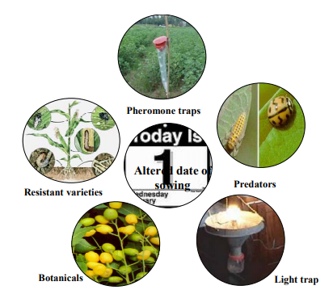
Fig 1: Modules of organic pest management (Source: http://docplayer.net/1739307-Pest-and-disease-management-organic-ecosystem.html)

Useful Tools for Pest Management
Develop a small library of pest-management reference materials.
Identify local experts (entomologists, plant pathologists, soil scientists) who are willing to respond quickly to questions.
Learn major pests (and their natural enemies) of your main crops, understand their lifecycles, and learn how to use a hand lens. Train other workers on your farm on pest and damage ID, as well.
Take digital pictures of unknown pests/ plant symptoms and send them to local experts for identification.
Have at least a good-quality backpack sprayer; larger farmers may want to have a tractor-based spray rig with internal agitation.

USDA Organic Regulations Relating to Pest Management
The organic standard for crop pest, weed, and disease management specifies the following:
(a) The producer must use management practices to prevent crop pests, weeds, and diseases including but not limited to:
(1) Crop rotation and soil and crop nutrient management practices.
(2) Sanitation measures to remove disease vectors, weed seeds, and habitat for pest organisms; and
(3) Cultural practices that enhance crop health, including selection of plant species and varieties with regard to suitability to site-specific conditions and resistance to prevalent pests, weeds, and diseases.
(b) Pest problems may be controlled through mechanical or physical methods including but not limited to:
(1) Augmentation or introduction of predators or parasites of the pest species;
(2) Development of habitat for natural enemies of pests;
(3) Non-synthetic controls such as lures, traps, and repellents.
(c) Weed problems may be controlled through:
(1)Mulching with fully biodegradable materials;
(2) Mowing;
(3) Livestock grazing;
(4) Hand weeding and mechanical cultivation;
(5) Flame, heat, or electrical means; or
(6) Plastic or other synthetic mulches: Provided, that, they are removed from the field at the end of the growing or harvest season.
(d) Disease problems may be controlled through:
(1) Management practices which suppress the spread of disease organisms; or
(2) Application of non-synthetic biological, botanical, or mineral inputs.
(e) When the practices provided for in paragraphs (a) through (d) of this section are insufficient to prevent or control crop pests, weeds, and diseases, a biological or botanical substance or a substance included on the National List of synthetic substances allowed for use in organic crop production may be applied to prevent, suppress, or control pests, weeds, or diseases: Provided, That, the conditions for using the substance are documented in the organic system plan.
(f) The producer must not use lumber treated with arsenate or other prohibited materials for new installations or replacement purposes in contact with soil or livestock (USDA, 2020).

3.5. Organic pest management methods:
Methods of organic pest management can be categorized as
- Cultural
- Physical/Mechanical
- Biological
- Organic pesticides
- Genetic (Thapa, 2004; Ladonski, 2019)
- Cultural method: This method involves the use of farm practices to prevent or control pests especially on the field. This reduce pest establishment, reproduction, dispersal, and survival (Hill, 1987). Examples of cultural control include:

- Sanitation and good husbandry: Collection and destruction of crop residues and needs after harvest of crops prevent the multiplication of borers and other pests for the coming season. Many insects hide or hibernate under loose bark in deep or unhealthy branches of trees. Removal of such shelters by scrapping, pruning or plastering would prevent multiplication of borer and bark eating caterpillars.
Removal and destruction of | Control of
Rubbish | Coconut beetle
Infested fruits | Fruitflies, coffee fruit borer
Early pods | Cocoa pod borer to break continuity
Potato cull piles | Potato late blight fungus
(Source: Thapa, 2004)
- Tillage: Deep plowing of field is a good method of controlling many insects, diseases, nematodes and weeds. Tillage reduces the pest by:
- Mechanically damaging the pest
- Burying or exposing a developmental stage of the pest
- Changing physical condition (pH, moisture, oxygen content) of soil
- Eliminating the alternate or main host plants and
- Hastening the growth vigor of crops (Carcamo, 1995; Walgenbach, 2018)
Few examples (Thapa, 2004):
- Some control of white grubs, wireworms, cutworms can be achieved by this method.
- Also significantly reduces Meloidogyne incognita of tobacco
- Tillage controls wheat disease 50% in tillage and only 17% in no tillage
- Crop rotation: Crop rotation exerts most pressure on pests which have a narrow host range and limited mobility. This method is used to break the life cycle of insect pests and nematodes (Bullock, 1992).
Few examples (Thapa, 2004):
- Alteration of cereal and legume crops
- Prohibition of growing potato in the affected areas for a season results elimination of potato tuber moth
- For weed control, crops that are fast growing and can out-compete weeds (e.g. winter squash, potatoes, sweet corn and tomatoes) are smart addition.
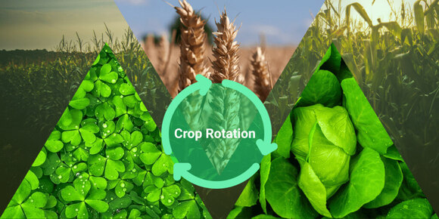
Types of crop rotation (Thapa, 2004):
- Single cropping rotation: Blister beetle damage cowpea flower in a minute but when planted in rotation, damage is low.
- Inter-cropping: Intercropping of maize and groundnut markedly decreased corn borer damage in maize because of increased spider activity due to groundnut.
- Stripe cropping: Rosette virus disease is less when corn and groundnut grown than mono of groundnut.
- Trap cropping: Trap crops limit pest incidence in one or more ways, including the following:
- By acting as a barrier or hazard or a camouflage
- By acting as alternate host diverting the pest away from main crop and
- By benefiting natural enemies of the pest
For example: Okra plants attract bollworms and red cotton bug. Therefore, planting a few rows of okra on cotton field helps to attract those pests.
- Use of manure and fertilizers: Healthy plants raised with balanced plant nutrients are less infested with pest than excess or less fertilization (Eigenbrode & Pimentel, 1988; Ravi, Dhandapani, Sathiah & Murugan, 2006).
- Wheat grown on P deficit soil is damaged more by wireworms, and stem fly than those grown on P balanced lands.
- Excess of nitrogenous fertilizer increase incidence of borers, plant hoppers and gallmidge in rice
- Excess of potash and phosphorus reduces the incidence of aphids and gallmidge
- Time of sowing and harvesting: Only a few pests like aphids can damage to crops over a prolonged duration covering different stages of plant growth. Most of the pest cause damage to a particular stage of the crop or appear only during certain period of years. Manipulation of sowing and harvesting time help to escape crops from pest damage (Thapa, 2004; Zhu, Zhu, Feng, Cai, Zhong & Cheng, 2011; Kalyan & Ameta, 2017).

Few examples:
- Early sowing of
- sorghum against sorghum midge,
- mustard against mustard aphid
- cucurbits against red pumpkin beetles
- Early harvesting of wheat against rust
- Quality seeds: The very first event in the cultivation of any crop is selection of seeds, seeds should be healthy and good (Crawley, 2000; Thapa, 2004).
- Seed borne pests like some nematodes and cockle seed of wheat may serve as potential source of field infestation.
- Use of resistant varieties: The resistance of plants to pest attack may be due to non-preference, antibiosis or tolerance (Wyss, Luka, Pfiffner, Schlatter, Gabriela & Daniel, 2005).
- Use of resistant variety like of MM series of apple against wooly apple aphid (Blommers, 1994).
- Physical method: This involves the manipulation of temperature, humidity, and use of radiant energies. These methods are particularly useful for destroying stored grain pests (Fields & Muir, 1996; Weintraub & Berlinger, 2004).

Manipulation of Temperature:
- High temperature: Most of the insects are killed in a short time when they are exposed to high temperature of 60-66 ⁰C. This principle has been employed for killing stored grain pests by superheating the empty godowns. Drying infested stored products in sun for 3-4 hours in summer also kills and prevents store grain pests. Godowns can be heated by hot water pipes or by electricity (Dosland, Subramanyam, Sheppard & Mahroof, 2006).
- Burning: Flame thrower with kerosene fuel have been used for burning the adults and nymphs of desert locusts on deserts, barren lands and shrubs in the uncultivated areas (Thapa, 2004).
- Low temperature: Nearly all insects become inactive at 60-40 ⁰F. Practically no damage occurs from insects at temperature below or near freezing point will prevent all insect damage (Denlinger & Lee, 2010).
- Manipulation of moisture: Drying of grains (<10% moisture) before storage is a sound practice to prevent insect damage by stored grain pests (Fields & Korunic, 2000; Thapa, 2004).

Manipulation of light:
- Light traps: Several species of insect pests mostly nocturnal are attracted to light (Shimonda & Honda, 2013).
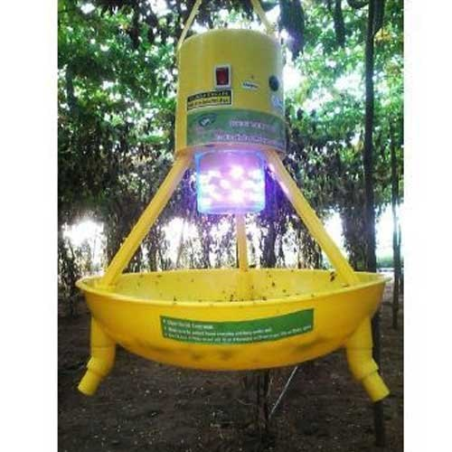
- Unattractive lamps: The use of yellow or red lamps reduces the nuisance of insects that are attracted to ordinary or UV lamps. Sodium vapor lamps involve higher initial costs but produce higher lumen out-put with less input wattage and do not attract many insects (Thapa, 2004).

- Use of radian energy: The atomic energy consists of X-rays, B-rays, G-rays. All these rays are effective in causing the death of tissues and sterility in insects. G-rays are being used for disinfection of stored products. Cobalt-60 source of G-radiation is used to sterilize the pupae of screw-worm fly (Fields, 1994; Thapa, 2004).
- Use of sound wave: Male mosquitoes are attracted by special sound waves and made sterile by electronic flash gun. Recently, sound gun has been invented to scare monkey (Thapa, 2004).

- Mechanical method: This method involves the use of mechanical devices or manual operations for the control of pests (Thapa, 2004; Ladonski, 2019).
It includes following practices:

Destruction:
- Hand picking: Usually large size insects (caterpillar, bugs) and their egg masses are hand-picked and destroyed. Mostly applicable for cabbage caterpillar, the hairy caterpillars, the tobacco caterpillars (Walgenbach, 2018).
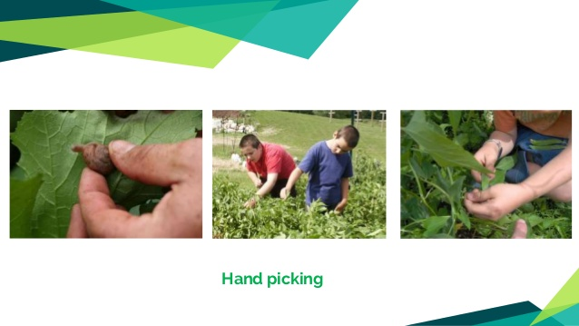
- Shaking or beating: Infested plants and their branches are shaken or beaten with a stick to drive among the pests (Thapa, 2004).
- Locusts are driven or killed by beating plants with brooms or twig of plants.
- Mustard sawfly can be shaken off the plants into a flat vessel containing kerosene and water.
- Sieving and winnowing: Insects of stored grains are removed by sieving and/or winnowing.

Exclusion:
- Banding: The use of 5 cm wide sticky/greasy band around the trunk of a mango tree, before hatching eggs of mango mealy bug in the soil prevents upward movement of nymphs (Mohyuddin & Mahmood, 1992; Thapa, 2004).

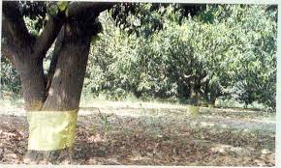
- Wrapping of fruits:
- Bunches of grapes are wrapped in muslin bags to protect from wasps and bees.
- Pomegranate fruits are covered in bags to protect from butterfly laying eggs on them.
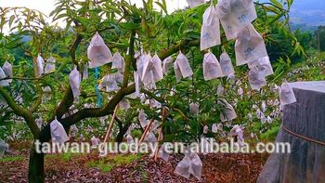
- Net screening: Use of protective covers to prevent the entry of insects, pathogens, animals.
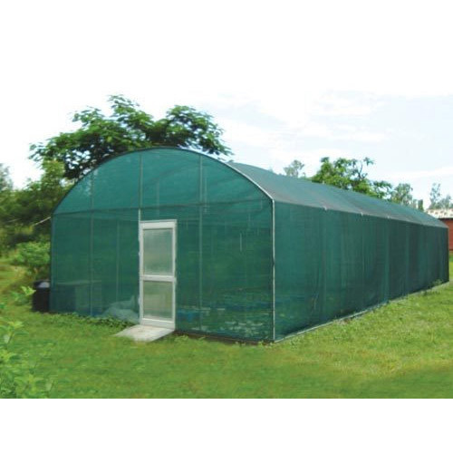
- Trench digging: The digging of 30-60 cm wide and 60 cm deep trench around the field gives protection to the crops from the attack of migrating insects such as hairy caterpillars, grasshopper and locust nymphs.
- Pest smashing/collecting devices: These devices include hopper-dozers, aphid dozers which smash and collect pests by running over them.
- Use of water barrier: The legs of food or plant cabinets, cages are kept dipped in water pots and water trench around field prevents entry of ants and other insects.
- Sticky/water pan trapping: Different traps can be devised such as sticky or water-pan, sound trap, suction traps etc. Aphids and whiteflies are attracted by yellow pan trap. Sound traps are used to scare the insects away.
- Use of different insect attractants/repellents: Food attractants like methyl eugenol against fruitfly. Likewise, sex attractants, sex pheromones, oviposition attractants can be used. Corn extract attracts corn earworm to oviposit. Dhatura plant repels white flies from tomatoes. Carrot fly doesn’t attack carrot in carrot-onion crop mixture.
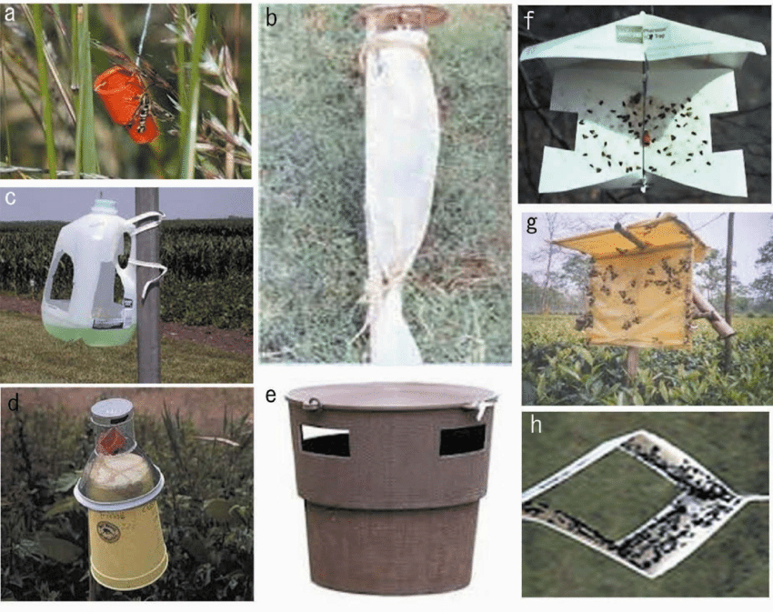
- Use of organic or plastic mulches: Mostly useful in controlling weeds. Also, few mulches like silver plastic mulch has property to repell insect pests (Ccizinszky, Schuster & Kring, 1995; Thapa, 2004).

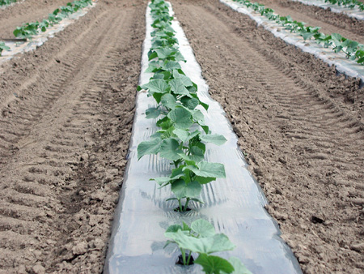

Small scale eradication to control various diseases like:
- Loose smut of wheat
- Covered smut of barley
- Red rot of sugarcane
- Wilt of arhar and many others

- Biological Method: This involves the introduction of the natural enemies- predators, parasites, pathogens, and competitors of pests to control or keep the pest population under control. Pathogenic microbes like viruses, bacteria, fungi, nematodes, protozoa are used for this purpose. Invertebrates, plant pathogens, nematodes, weeds, and vertebrates have many natural enemies. Such enemies eat up or feed on these pests thereby reducing the population of the pests. As this method does not pose any environmental threat, besides inexpensive it has therefore, gained significant prominence (Flint & Dreistadt, 1998).

Insect predators
Predators | Prey/insects
Lady bird beetle | Aphids, scale insects & mealy bugs
Praying mantid | Moths & other weaker insects
Syrphid flies | Maggots & aphids
Tiger beetle | Rice ear head bug
Lacewings | Colorado potato beetles, many caterpillars, borers, corn earworms, leafhoppers, whiteflies
Ground beetles | Corn earworms, asparagus beetles, cabbage worms
(Source: Thapa, 2004)
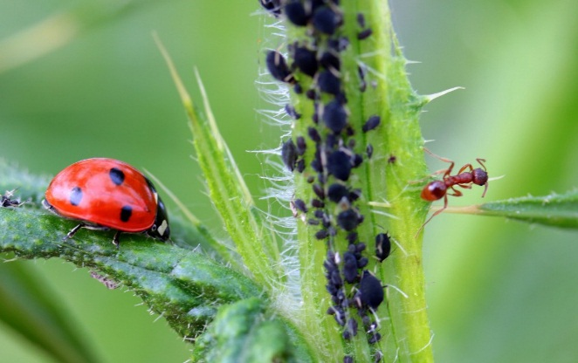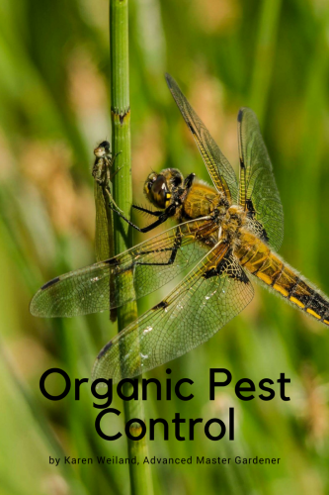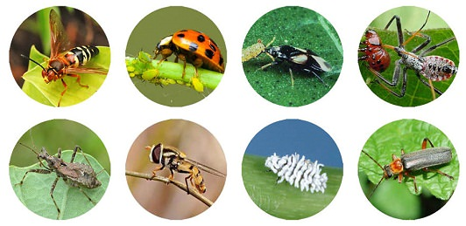

Predatory vertebrates
Vertebrates | Insects
Birds (House sparrow, mayna, crow & many others) | Many insect pests
Mammals (Bats, shrew, mongoose) | Many insect pests
Amphibian and reptiles | Insects, frogs
Fishes | Mosquito larvae & chironmid larvae
(Source: Thapa, 2004)

Insect parasites/parasitoids
Parasites | Host | Types
Apanteles flavipes | Chilo partellus | Larval
Trichogramma minutum | Chilo partellus & other insects | Egg
Xanthopimpla predator | Chilo partellus | Pupal
Tricholyga sorbillans & T. bomycis | Bombyx mori | Larvae & pupae
(Source: Thapa, 2004)

Parasitic fungi:
Fungi | Host
Aspergillus | Skippers
Beauveria | Diptera
Metarrhizium anisopliae | Sugarcane Pyrilla & larvae of chaffer, mosquito
Spicaria | Diptera, hemiptera, Lepidoptera & coleopteran adults
Entomophora lacanii | Scale insects, coffee green
Entomophthora sphaerosperma | Cabbage butterfly, leaf hopper
Entomophria grylli | Grasshopper
Coccus viridis | Scale insects
(Source: Thapa, 2004)

Pathogenic Protozoa:
Protozoa | Host
Nosema bombycis | Silkworm
Malpiaghamoeba melliferae | Honeybee
Malpiaghamoeba locustaceace | Grasshopper
Xanthomous grandis | Beetles, grasshopper & butterflies
(Source: Thapa, 2004)

Pathogenic bacteria and viruses

S.N. | Biological Agents | Pest | Crop
1. | Trichogramma brassiliensis- 1.0 cc/ac. once in 10 days, (Egg parasitoid) | Lepidopteran, Heliothis sp | Cotton, Tomato
2. | Trichogramma chilonis – 2 cc/ac  once in 15 days | Borers | Sugarcane, paddy, pulses, vegetables
3. | Nuclear Polyhedrosis Virus (NPV) 100-200 LE/ac | Spodoptera sp & Heliothis sp | Vegetables
4. | Chrysoperla sp 500-10000 eggs/ha, 3-4 times in 15 days, (Green lace wing) | Prudenia, Caterpillars, white flies, thrips, aphids | Vegetables
5. | Beauveria bassiana- 1.0% Affects the young stage | Helicoverpa, spodoptera, borers, hairy caterpillars, mites, scales, etc. | Vegetables, cereals, fruits
6. | Metarhizium anisopliae – 0.5-1.0 % affects all stages | White grubs, beetle grubs, caterpillars, semiloopers, mealy bugs, BPH | Sugarcane, groundnut, rice, potato, cotton, cereals
7. | Verticillium lecanii – 0.5-1.0 % affects all stages | All sucking soft bodies insects | Sugarcane, groundnut, rice, potato, cotton, cereals
8. | Phascilomycetes | Nematodes | All crops
9. | Bacillus thuringiensis var kustaki | Helicoverpa, spodoptera, borers, hairy caterpillars, mites, scales, etc. | Vegetables, cereals, fruits
10. | NPV- Nuclear Polyhedrosis Virus | Spodotera litura | Cotton, groundnut, pulses, cabbage, chillies
11. | NPV – Nuclear Polyhedrosis Virus of Helicoverpa armigera 250- 500 ml/ha, 2-3 time at 10 days interval | Helicoverpa armigera | Cotton, groundnut, pulses, cabbage, chillies
(Source : Thapa, 2004)
- Pathogenic nematode: Neoaplectana carpocapsae used for controlling codling moth.

Biological control of plant pathogens (Pal & Gardener, 2006):
- Trichoderma viridae parasites Verticellium wilt.
- Streptomyces, Nocardia, Psendomonas, Bacillus isolated from soil are capable of causing lysis of Fusarium spp
- Penicillium chrysogenum, Penicillum vermiculalum parasites Rhizoctoria solani
- Didymella exitialis kills hyphal cells of Ophiobolus graminus (wheat)
- Gliocladium soreum parasitizes and destroys conidia of many species of fungi.
- Dactylaria spp are good nematode trapping fungi.
- Residue of Datura stranomim is used for controlling Spongospora subterranean (powdery scab of potato).
Pal, K. K., & Gardener, B. M. (2006). Biological control of plant pathogens. Retrieved from apsnet.org

Biological control of weeds
Bioagent | Weeds
Beetles (Octotoma scabripennis & Uroplata giraldi) | Lantana camara
Scale insect | Prickly-pear weed
Flea beetles | Alligator weed- Alternanthera philoxeroides
Common carp, Chinese carp | Aquatic weeds
Mammals (Sea cow) | Water hyacinth
Snails (Marisa sp & other fresh water snails) | Submerged weeds like coontail and algae
Fungi (Rhizoctinia) | Hyacinth
Mites (Tetranychus sp) | Prickly pear
(Source: Sharma, 2018)
- Organic pesticide method: Pesticides other than of chemical source mostly of plant origin which doesn't have negative effect on soil, environment and health of plant, animals and humans (Guleria & Tiku, 2009).
Few examples are:
- Neem oil: It is extracted from neem plant which inhibits the growth cycle of insects. Its active ingredient, Azadirachtin, will cause infected insects to eat less, grow more slowly, and molt less. This works best on young insects and insects that grow rapidly like squash bugs, Colorado potato beetles & Mexican bean beetles. It is also effective on smaller, leaf-eating caterpillars and aphids.
- Nicotine: Extracted from tobacco plant, nicotine is most widely used and effective organic pesticide used against aphids, thrips, hoppers and leafminers.
- Rotenone: An organic pest killer occurring naturally in seeds and stems of some plants. It kills leaf-feeding caterpillars, beetles, aphids and thrips on vegetables and fruit crops.
- Pyrethrin: One of the most widely used botanical insecticide, extracted from chrysanthemum plant. This insecticide is a powerful, fast-acting deterrent, even at low doses. Upon exposure, most flying insects will immediately drop but may not always be killed.

Table 4: Liquid extracts for disease management
Disease | Type of compost
Late blight of potato, tomato | Horse compost extract
Gray mold on beans strawberries | Cattle compost extract
Downy and powdery mildew of grapes | Animal manure-straw compost extract
Powdery mildew on cucumbers | Animal manure-straw compost extract
Gray mold on tomato, pepper | Cattle and chicken manure compost extract
Apple scab | Spent mushroom compost extract
(Source: Kumar, 2012)

- Genetic method: Genetic alteration to reduce pest impacts is not as widely known or publicly available as other control options. Autocide is one type of genetic control and involves using the pest itself to induce increased mortality rates. Sterile males are introduced into the population, which, after mating with females, creates infertile eggs. This is an expensive option with many limitations including potential for reduced competitive viability of the introduced sterile males. Straightforward genetic manipulation to create pest resistant plant strains is another form of controlling pest impacts. However, genetic manipulation research and development is costly, and introduces a whole other series of ethical and environmental issues that are not easily addressed. Genetic manipulation is not a viable control option for the general public (Klassen, 2005).

Advantages of organic pest management
- To the agricultural producers: By reduction in the producer economic risk, by the promotion of low cost of carefully targeted pest.
- To the environment: By the promotion of sustainable bio based pest management alternatives.
- To pest management professionals and organizations: As a result of demand for new, innovative and marketable products and services.
- To the general public: Assurance of safe, reliable, low cost pest control through improved pest management.

Disadvantages of organic pest management
- Organic pest management systems are extremely complex and require a higher level of understanding to utilize
- An OPM system of pest control involves a lot more time and is sometimes more costly than the traditional method of spraying pesticides to eliminate pests.
- In order for an OPM to work effectively, it needs constant monitoring.
- Also, the natural enemies of pests used in some OPMs can later become pests themselves.

CONCLUSION:
Organic pest management is a key factor in organic agriculture which is gaining popular these days. Organic pest management is a holistic approach of insect pest, disease and weed management following the physical, mechanical, cultural, genetic, biological and organic pesticide method avoiding the use of synthetic chemical products. No single management method is solely effective in controlling the pest. Early priority should be given to physical, mechanical, cultural and biological methods and organic pesticide method should be considered as last option if needed only. Use of chemical products is not allowed. Besides increase in yield only through use of chemical pesticides, eco-friendly sustainable agriculture is an important aspect which can be achieved through organic pest management practices. Thus, judicious use of organic pest management is a key driving force for sustainable livelihood too which shows utmost importance for its adaptation.

REFERENCES
Blommers, L. H. (1994). Integrated pest management in European apple orchards. Annual Review of Entomology, 39(1), 213-241.
Bullock, D. G. (1992). Crop rotation. Critical reviews in plant sciences, 11(4), 309-326.
Csizinszky, A. A., Schuster, D. J., & Kring, J. B. (1995). Color mulches influence yield and insect pest populations in tomatoes. Journal of the American Society for Horticultural Science, 120(5), 778-784.
Crawley, M. J. (2000). Seed predators and plant population dynamics. Seeds: the ecology of regeneration in plant communities, 2, 167-182.
Denlinger, D. L., & Lee Jr, R. E. (Eds.). (2010). Low temperature biology of insects. Cambridge University Press.
Dosland, O., Subramanyam, B., Sheppard, K., & Mahroof, R. (2006). Temperature modification for insect control. Insect management for food storage and processing, 89-103.
Eigenbrode, S. D., & Pimentel, D. (1988). Effects of manure and chemical fertilizers on insect pest populations on collards. Agriculture, ecosystems & environment, 20(2), 109-125.
Fields, P. G., & Muir, W. E. (1996). Physical control. Integrated management of insects in stored products, 195-221.
Fields, P., & Korunic, Z. (2000). The effect of grain moisture content and temperature on the efficacy of diatomaceous earths from different geographical locations against stored-product beetles. Journal of Stored Products Research, 36(1), 1-13.
Flint, M. L., & Dreistadt, S. H. (1998). Natural enemies handbook: the illustrated guide to biological pest control (Vol. 3386). Univ of California Press.
Guleria, S., & Tiku, A. K. (2009). Botanicals in Pest Management: Current Status and Future Perspectives. In: Integrated Pest Management: Innovation-Development Process, 317-329
Hill, S. (1987). Cultural Pest Control. American Journal of Alternative Agriculture, 2(4), 53-58.
Kalyan, R. K., & Ameta, O. P. (2017). Effect of sowing time and varieties on incidence of insect pests of soybean. J. Entomol. Zool. Stud, 5, 790-794.
Klassen, W. (2005). Area-wide integrated pest management and the sterile insect technique. In: Sterile Insect Technique (pp. 39-68). Springer, Dordrecht.
Kumar, B. (2012). Botanical pesticides in plant disease management. In Eco-friendly Innovative Approaches in Plant Disease Management (p. 710). Dehradun, India: International Book Distributors.
Ladonski, A. (2019, August 29). Organic Pest Control Methods. Retrieved from SDSU Extension: https://extension.sdstate.edu/organic-pest-control-methods
Mohyuddin, A. I., & Mahmood, R. (1992, July). Integrated control of mango pests in Pakistan. In IV International Mango Symposium 341 (pp. 467-483).
Pimentel, D. (2009). Pesticides and Pest Control. In Integrated Pest Management: Innovation-Development Process (pp. 83-87).
Poudel, S. (2020, June 2). Native Knowledge: Organic Pest Management in Nepal. Retrieved from Agrilinks: https://www.agrilinks.org/post/native-technical-knowledge-organic-package-insect-pest-management-nepal
Ravi, M., Dhandapani, N., Sathiah, N., & Murugan, M. (2006). Influence of organic manures and fertilizers on the incidence of sucking pests of sunflower, Helianthus annuus L. Annals of Plant Protection Sciences, 14(1), 41-44.
Sandler, H. A. (2010). Integrated Pest Management. Cranberry Station Best Management Practices, 1(1): 12-15.
Sharma, A. (2018). Biological Control of weeds. Presentation. Retrieved from: https://www.slideshare.net/AjaySharma1059/1-biological-control-of-weedsajay-sharma
Shimoda, M., & Honda, K. I. (2013). Insect reactions to light and its applications to pest management. Applied Entomology and Zoology, 48(4), 413-421.
Stoleru, V., & Sellitto, V. (2016). Pest Control in Organic Systems. DOI: 10.5772/64457
Thapa, R. (2004). Lecture Notes on Insect Pest Management.
USDA. (2020). National Organic Program (NOB) Handbook. Retrieved from USDA Agricultural Marketing Service: https://www.ams.usda.gov/rules-regulations/organic/handbook
Walgenbach, J. F. (2018). Integrated Pest Management Strategies for Field-Grown Tomatoes. Sustainable Management of Arthopod Pests of Tomato.
Weintraub, P. G., & Berlinger, M. J. (2004). Physical control in greenhouses and field crops. In Insect pest management (pp. 301-318). Springer, Berlin, Heidelberg.
Wyss, E., Luka, H., Pfiffner, L., Schlatter, C., Gabriela, U., & Daniel, C. (2005). Approaches to pest management in organic agriculture: a case study in European apple orchards. Cab International: Organic-Research. com May 2005, 33N-36N.
Zhu, J., Zhu, Z., Feng, J., Cai, X., Zhong, X., & Cheng, J. (2011). Effect of sowing/transplanting time on occurrence of main locally-overwintering insect pests and diseases. Acta Agriculturae Zhejiangensis, 23(2), 329-334.

